Software Requirements Specification
<<VERSION 1.0>>

3C(Create Consummate Campus) System
——A voting evaluation system

Team Name: MissPoem
Name: Niannian Li, Shiyun Liu
Course: Advanced Software Paradigms
Professor: Dr. A. Bellaachia
Date: Oct. 6th., 2012

Document History and Distribution

- Revision History

Revision # | Revision Date | Description of Change | Author
None

- Distribution

Recipient Name | Recipient Organization | Distribution Method

Table of Contents

1. Introduction 1
1.1 Target Users 1
1.2 Purpose 1
1.3 Scope 1
2. Environment 2
2.1 Application Environment 2
2.2 Development Environment 2
3. Architecture 2
4. Functional Requirements 3
4.1 Basic Function Modules 4
4.2 Basic Use Cases 4
4.2.1 Overall Use Case Diagram 4
4.2.2 Login 5
4.2.3 Manage Personal Information 6
4.2.4 Vote 7
4.2.5 Manage Own Voting Information 8
4.2.6 Manage All Information 11
4.3 Extended Functions 13
5. Non-Functional Requirements 14
5.1 Usability 14
5.2 Reliability 14
5.3 Performance 14
5.4 Maintainability 14
5.5 Implementation 14
6. Notes 14
7. Reference 15

- Introduction
This project is named 3C ( Create Consummate Campus ) system. It’s a voting evaluation system on campus. Users can cast votes and publish its own votes with many other operations by using this system.

  - Target Users
There are three groups of target users in this project: Students, Faculty and Administrators. Students and Faculty have the same authorities and functions. The reason of separating them into two defferent user groups is that some votes aim at only one group of them and the other group can not vote. For example, Faculty can not cast a vote whose topic is “Who is your favorite teacher”. This kind of votes only aim at students.
- Students:
Students can present their opinions of their schools or faculty (professors) by voting and they can also add vote topics and waiting for others’ voting in order to know more about their schools or faculty.
- Faculty:
Faculty can present their opinions of their schools or students by voting and they can also add vote topics and waiting for others’ voting in order to know more about their schools and student.
- Administrators:
The administrators should manage the users’ login information and the voting information like receiving delations and deleting the unqualified votes. Also, they can publish votes as a representative of the school and will get a lot of information which will help the school and the faculty to improve themselves.

  - Purpose
- Make students, faculty know more about the campus by using this voting system.
- Provide a platform of communication between students, faculty and school officials.
- Facilitate the improvment of the three groups of users and make a contribution to creating consummate campus.

  - Scope
This document contains five sections and appendix. The five sections are: Introduction, Environment, Architecture, Functional Requirement, Non-Functional Requirement. The appendix talks about the database and ….

- Environment

  - Application Environment
Fig 2.1 shows a diagram of this 3C system environment.

Server
Internet
PC1
User 1
PC2
PC3
…
。。。。
PCn
User 2
User 3
User n
Broswer
…
Broswer
Broswer
Broswer
Database
Fig. 2.1 Application Environment Diagram of 3C system

It’s easy to find that
- Users should have a PC,
- The browser has been installed on the PC and now is available.
- The PC has been connected to the network successfully.
- Memory requirements of PC is more than 1G

  - Development Environment
- Dreamwaver: Design and landscape the front interface of webpages.
- myEclipse: Develop backgroud program by JAVA language.
- MySQL: Provide database service for this application.

- Architecture
This program is based on B/S architecture. B/S is short for Browser/Server, which is a variation or development of C/S ( Client/Server ) architecture. By using this architecture, user interface is realized by the www browser with a few behaviors of transaction logic. The main behaviors of the transaction logic are in the server.It simplifies the missions and reduces the heavy burdens of client-side. It also reduces the cost and workload of system maintainance. Fig. 3.1 shows the B/S architecture of this 3C system.

Display
Transaction Logic
Database
Front Browser
Web Server
Database Server
Request
Request
Response
Response
Fig. 3.1 Architecture Diagram of 3C system

It’s a 3-tier architecture which contains Display layer, Transaction Logic Layer and Database Layer. There are some advantages of this structure:
- Open standards: Standards for B/S are all open and unspecialized which provides generality and cross-platform ability.
- Low cost of development and maintainance: Applications based on B/S are used on the browser, so users only need to install the generic browser. Maintainance and update operation will be taken on server.
- Easy use for users: The user interfaces of B/S applications are always user-friendly.

So we use B/S 3-tier architecture.

- Functional Requirements
This project contains many function modules and the main is voting. The basic functions that we need to realize are as follows. And the extended functions which can be realized if allowing more time and energy are added behind the basic funcions.
  - Basic Function Modules
Fig. 4.1 shows the function modules of 3C system.

Voting System
Identify Module
Voting Module
Administrators Module
Students Module
General Users Module
Faculty Module
Fig. 4.1 Function Module Diagram of 3C system

There are four main modules of the voting system:
  - Identify Module: Identify the users’ identities by logging on and logging in. After that, different users have different authority.
  - Voting Module: Cast votes in this system.
  - Administrators Module: Administrators can manage all informations of this system.
  - General Users Module: This module contains two sub-modules. One is Students Module which can create, delete, modify and search votes and can also manage the personal information. They other is Faculty Module which has the same function of Students Module.

  - Basic Use Cases
    - Overall Use Case Diagram
The overall use case diagram is as the Fig. 4.2 below.
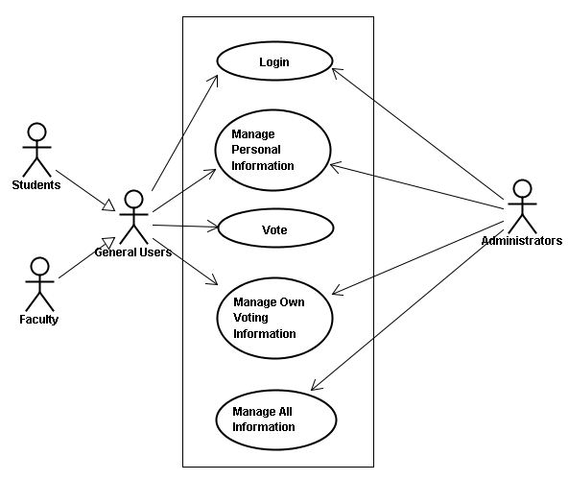
Fig. 4.2 Overall Use Case Diagram

There are five main functions of this system for the three groups of users. Students and Faculty are looked as the General Users. They can Login the system, manage their personal information, cast a vote and manage their own voting information.

    - Login
Fig 4.3 shows the login use case diagram.
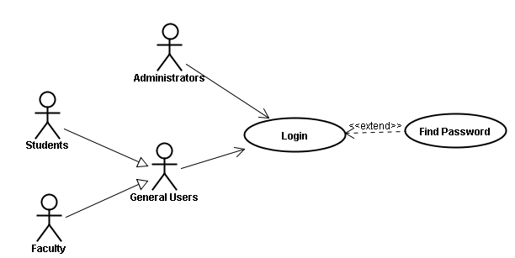
Fig. 4.3 Login Use Case Diagram

Login function is like a door to access the system. If identifying the three groups of users’ identity is successful, the users can use this voting system under their limits of authority.
In this system, all general users’ informations are typed in by administrators, so it’s no need to log on. When logging in, the user name is the ID of the general users.

Table 4-1 is the description of “login use case”.

Table 4-1 Login Use Case
Use case 1 | Login
Actors | Students, Faculty and Administrators
Summary | Students, faculty and administrators can get into our website after login.
Preconditions | Students, faculty and administrators have opened our website.
Detailed description | 1,input student ID and password  2,press "login" button
Post-conditions | Students, faculty and administrators get into the homepage.
Special requirement | Students, Faculty and Administrators can find their password when they forget their password.  1,press the “forget password” button  2,input name and student ID  3,press the "submit" button  Then they can get their password.

    - Manage Personal Information
Fig 4.4 shows the manage personal information use case diagram.

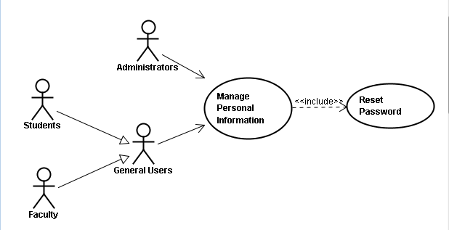
Fig. 4.4 Manage Person Information Use Case Diagram

Manage personal information function means reseting or updating users’ password. All users can manage their personal informations. Because the user name (ID) is fixed, the users can only modify the passwords.

Table 4-2 is the description of “manage personal information use case”.

Table 4-2 Manage Person Information Use Case
Use case 2 | Manage Personal Information
Actors | Students, Faculty and Administrators
Summary | Students, faculty and administrators can change their password.
Preconditions | Students, faculty and administrators have logged in.
Detailed description | 1,press the “reset” button  2,input old password and new password  3,press the "submit" button
Post-conditions | Students, faculty and administrators get their new password.

    - Vote
Fig 4.5 shows the vote use case diagram.

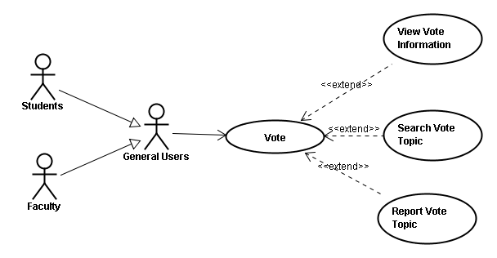
Fig. 4.5 Vote Use Case Diagram

Only general users can use the vote function which means casting published votes. Some other operations are allowed, like searching vote topics which they are interested in and viewing vote informations. If general users find that the vote they are looking at is illegal, they can report this vote to the administrators.

Table 4-3 is the description of “manage personal information use case”.

Table 4-3 Vote Use Case
Use case 4 | Vote
Actors | Students, Faculty
Summary | Students, faculty vote for topics on the homepage after login.
Preconditions | Students, faculty have logged in.
Detailed description | 1,view vote topics on the homepage  2,choose item to vote
Post-conditions | Students, faculty vote successfully.
Special requirement | Students, faculty sometimes may choose to view more details about vote topics before they vote, or input vote topics interest them to search for details, or report vote certain topics to the administrator.

    - Manage Own Voting Information
Fig 4.6 shows the manage personal information use case diagram.

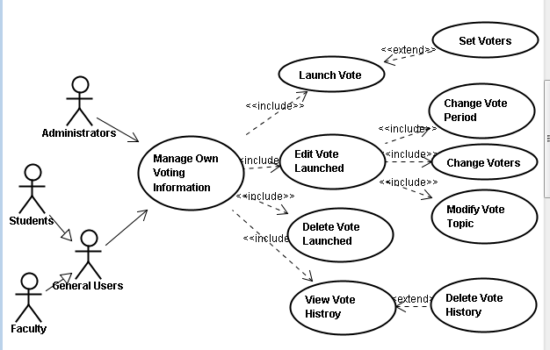
Fig. 4.6 Manage Own Voting Information Use Case Diagram

Manage own voting information function can be used by all the three groups of users. This function contains four sub use cases: Launch vote function, Edit launched vote function, Delete launched vote function and Manage vote history.

Table 4-4 is the description of “manage own vote information use case”.

Table 4-4 Manage Own Voting Information Use Case
Use case 3 | Manage Own Voting Information
Actors | Students, Faculty and Administrators
Summary | Students, faculty and administrators can launch vote, edit or delete vote launched and view vote history.
Preconditions | Students, faculty and administrators have logged in.
Detailed description | 1,choose Manage Own Voting Information on the homepage  2,choose certain functions
Post-conditions | Students, faculty and administrators successfully update their vote information.

Table 4-5 is the description of one sub use case which is “Edit launched vote function sub use case”

Table 4-5 Launch Vote Sub Use Case
Use case 3a | Launch Vote
Actors | Students, Faculty and Administrators
Summary | Students, faculty and administrators can launch vote by setting a vote topic and vote period
Preconditions | Students, faculty and administrators have logged in.
Detailed description | 1,choose Manage Own Voting Information on the homepage  2,choose launch vote item
Post-conditions | Students, faculty and administrators successfully launch a vote activity.
Special requirement | If the vote topic is not allowed faculty or students to vote, the launchers can select voters when they launch a vote.

Table 4-6 is the description of one sub use case which is “Launch vote function sub use case”

Table 4-6 Edit Launched Vote Sub Use Case
Use case 3b | Edit Vote Launched
Actors | Students, Faculty and Administrators
Summary | Students, faculty and administrators can change vote period, change voters, or modify vote topic
Preconditions | Students, faculty and administrators have logged in.
Detailed description | 1,choose Manage Own Voting Information on the homepage  2,choose Edit Vote Launched
Post-conditions | Students, faculty and administrators successfully edit the vote information

Table 4-7 is the description of one sub use case which is “Delete launched vote function sub use case”

Table 4-7 Delete Launched Vote Sub Use Case
Use case 3c | Delete Vote Launched
Actors | Students, Faculty and Administrators
Summary | Students, faculty and administrators can delete the vote they have launched.
Preconditions | Students, faculty and administrators have logged in.
Detailed description | 1,choose Manage Own Voting Information on the homepage  2,choose Delete Vote Launched
Post-conditions | Students, faculty and administrators successfully delete the vote they have launched.

Table 4-8 is the description of one sub use case which is “Manage vote history sub use case”

Table 4-8 View Vote History Sub Use Case
Use case 3d | View Vote History
Actors | Students, Faculty and Administrators
Summary | Students, faculty and administrators can view their vote history.
Preconditions | Students, faculty and administrators have logged in.
Detailed description | 1,choose Manage Own Voting Information on the homepage  2,choose View Vote History
Post-conditions | Students, faculty and administrators successfully view their vote history.
Special requirement | Students, faculty and administrators can delete their vote history if they want when they view their vote history.

    - Manage All Information
Fig 4.7 shows the manage all information use case diagram.

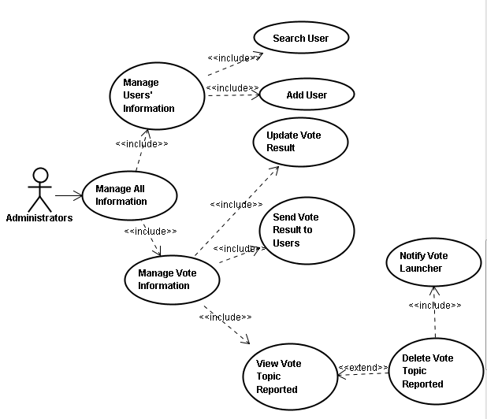
Fig. 4.7 Manage All Information Use Case Diagram

Administrators can manage all informations of this system. They can manage all users’ informations and manage all vote informations.
Note that all users’ informations are typed in by administrators. And when receiving a reported vote, administrators will view the vote and make a decision that if this vote needs to be deleted. If deleted, a notification will be sent to the vote launcher.

Table 4-9 is the description of “manage all information use case”.

Table 4-9 Manage All Information Use Case
Use case 5 | Manage All Information
Actors | Administrators
Summary | Administrators can manage vote information and users' information
Preconditions | Administrators have logged in.
Detailed description | 1,choose Manage All Information on the homepage  2,choose certain functions
Post-conditions | Administrators successfully update vote or users' information.

Table 4-10 is the description of one sub use case which is “Manage users’ informations sub use case”

Table 4-10 Manage Users’ Information Sub Use Case
Use case 5a | Manage Users' Information
Actors | Administrators
Summary | Administrators can search user or add user
Preconditions | Administrators have logged in.
Detailed description | 1,choose Manage All Information on the homepage  2,choose Manage Users' Information
Post-conditions | Administrators successfully find users' information or add new users.

Table 4-11 is the description of one sub use case which is “Manage vote informations sub use case”

Table 4-11 Manage Vote Information Sub Use Case
Use case 5b | Manage Vote Information
Actors | Administrators
Summary | Administrators can update vote result, send vote result to users, view vote topic reported.
Preconditions | Administrators have logged in.
Detailed description | 1,choose Manage All Information on the homepage  2,choose Manage Vote Information
Post-conditions | Students, faculty successfully manage vote information.

Table 4-12 is the description of one sub use case which is “View vote topic reported sub use case”

Table 4-12 View Reported Vote Information Sub Use Case
Use case 5b1 | View Vote Launcher
Actors | Administrators
Summary | Administrators can view the vote topics which have been reported by users.
Preconditions | Administrators have logged in.
Detailed description | 1,choose Manage All Information on the homepage  2,choose Mange Vote Information  3, choose View Vote Topic Reported
Post-conditions | Administrators successfully view the vote topics reported by users.
Special requirement | When the administrators get the report about certain vote topics, they can choose to delete the topics if necessary. After this action, the administrators should send a message to notify the vote launcher.

Table 4-13 is the description of one sub use case which is “Notify Vote Launcher sub use case”

Table 4-13 Notify Vote Launcher Sub Use Case
Use case 5b1a | Notify Vote Launcher
Actors | Administrators
Summary | Administrators should notify the vote launchers if their vote topics are deleted.
Preconditions | Administrators have logged in.
Detailed description | 1,choose Manage All Information on the homepage  2,choose Mange Vote Information  3, choose View Vote Topic Reported  4,choose Delete Vote Topic Reported  5,choose Notify Vote Launcher
Post-conditions | Administrators successfully notify the vote launcher.

  - Extended Functions
Apart from the basic functions, a lot of extended functions can be added into the system to make the website more interesting and colorful, so that users will get a comfortable relaxation from this happy entertainment.
Therefore, if more time and energy are allowed, more extended functions will be included in this project.
    - Grade the votes
Users can grade the votes to improve the quality of them. High grade votes will be displayed on the homepage.
    - Comment on the votes
Users can comment on the votes if necessary. They can complement more details after voting.
    - Search the personal vote history
If the users create a lot of votes, the amount of their history information must be huge. So searching their personal history is important.
    - Insert multimedia (like images, sounds, vedios,etc.) into Votes
Votes can contains multimedia, like images, sounds, vedios and so on to make this system more interesting and make the content of votes richer.
    - Carry out collecting point system
This system can carry out collecting point system. For example, when they create a vote, the users can get five points and casting a vote can get three points.

- Non-Functional Requirements
The non-functional requirements analysis is as follows.

5.1 Usability
This application contains user interfaces on the website. Users can view that from the browsers. The interfaces are friendly and it’s easy for users to understand the attributes of this application, learn how to use this system and handle operations.

5.2 Reliability
In this project, some extended operations are added to make sure that some frequently failure will not cause a fatal error. And after rebuilding the system, it’s easy to recover the data.

5.3 Performance
User interaction should incur very little penalty. Time and resources should be taken full advantage of.

5.4 Maintainability
This system should contain system logs so that administrators can maintain it easiliy and well.

5.5 Implementation
Correct result will be returned to user interfaces and security mechanism will be taken into this system, like limits of users’ authority.

- Notes
There are some notes for this system:
- Concurrency
If too many user send massages to the server at the same time, how will the server deal with the concurrency problems.
- Backups
The data in the database need to be backuped in order to prevent losting data when some exceptions occurr.
- Capacity
With using this system, more and more data will be stored into the database, so the capacity of database is an important issue.

- Reference
[1] Java: An Object Oriented Language by Michael A. Smith (frame- and cookie-dependent page images at Electric Press)
[2] Thinking in Java (second edition, with supplementary material) by Bruce Eckel (PDF, Word, RTF, and zipped text at mindview.net)
[3] Database Systems: Concepts, Languages and Architectures by Paolo Atzeni, Stefano Ceri, Stefano Paraboschi, and Riccardo Torlone (frame and cookie-dependent page images at Electric Press)
[4] HTML and JavaScript for Visual Learners (PDF with commentary at visibooks.com)
[5] CGI Programming on the World Wide Web (first edition, 1996) by Shishir Gundavaram (illustrated HTML at oreilly.com)
[6]Wiki
[7] Google and Baidu search engine

